## horizontal line



# [Automatic Signature Stability Analysis And Verification Using Local Features](https://github.com/swetanjal/Automatic-Signature-Stability-Analysis-And-Verification-Using-Local-Features)

27.09.2019

**─**

Teja Sai Dhondu(20171075)

Swetanjal Dutta(20171077)

Nishant Sharma(20171079)

# Project ID: #48

# Github Link:

<https://github.com/swetanjal/Automatic-Signature-Stability-Analysis-And-Verification-Using-Local-Features>

# Main Goals of the Project

1. To have a fully automatic system that can classify signatures as genuine, forged, disguised provided a few reference signatures are available in database.
2. Based on the implementation of the following paper:  
   <https://ieeexplore.ieee.org/stamp/stamp.jsp?tp=&arnumber=6981088&tag=1>
3. Achieve an error rate of <= 15% on the 4NSigComp2010 dataset, the most well known publicly available dataset of forensic signature verification competition

# Problem Definition

Present a novel signature stability analysis based on signature’s local / part-based features that can classify not only between genuine and forged signatures but also can recognise disguised signature. The signatures being classified must have their ground truth signature(reference signature) in our database.

We say a signature is disguised if someone signs with the intention of hiding his/her identity later.

Our project will be tested on the famous 4NSigComp2010 dataset. This is the first ever publicly available dataset containing disguised signatures.

We are yet to choose the implementation language.

# Algorithm

1. One of the unique features of the algorithm presented in this paper is that it makes use of local features of signature to classify it as genuine, fraud or disguised instead of globally classifying it.
2. When someone does a forged signature, it is observed that although there maybe global similarity with the reference signature, the local features are extremely different as shown below by the heat maps  
     
   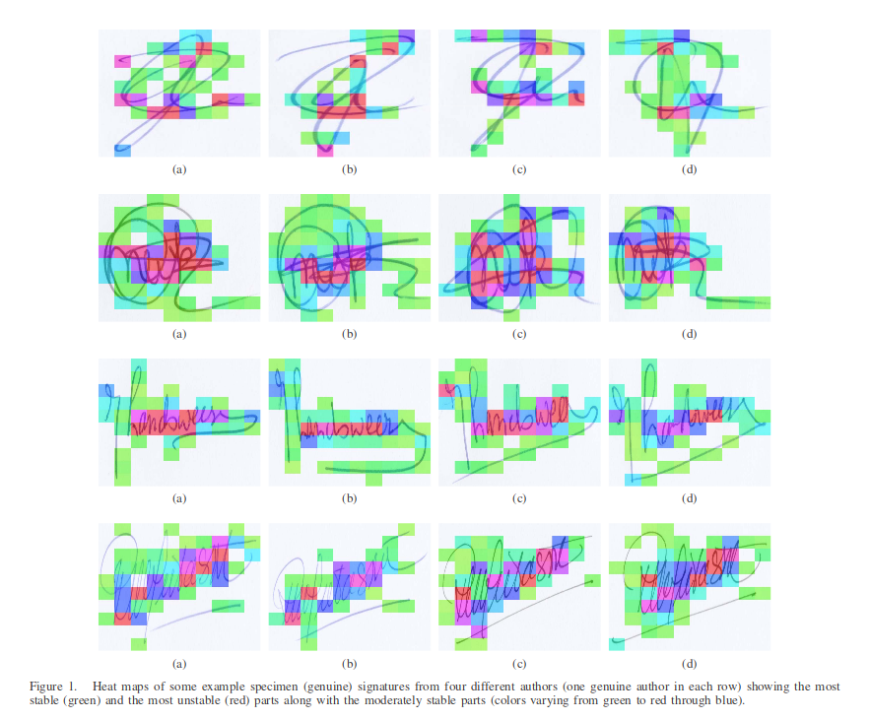
3. The local features are extracted using the famous SURF algorithm(very similar to SIFT)
4. Compute the key points from all the genuine specimen signatures of an author except only one genuine reference signature and make a temporary key points database.
5. Compute the key points from the remaining genuine reference signature and compare the distances of all of its key points from the temporary key points database.
6. Find the average distance and then mark all key points having distance less than or equal to the average distance as green and all other keypoints red.   
   The below image shows a visual representation of this step.  
     
     
   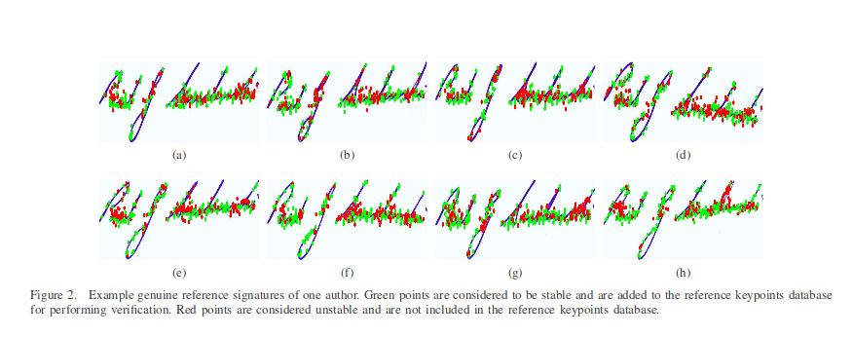
7. Repeat the above step for every genuine specimen signature in an ‘n-1 cross validation manner’ and populate a final reference key points database using only the stable key points(corresponding to the green regions in the visual example above) from different reference/specimen signatures.
8. Once the final reference key points database is created, key points and descriptors are extracted for the query/questioned signature. A comparison is made between the query signature key points and the key points present in our final reference key points database for that particular author.
9. Find the local key points from the query signature by using SURF. Then take the first keypoint of the query Image and compare it with all the features present in the final reference key points database, one by one. If a query signature keypoint is at a distance less than an empirically found threshold θ, note the keypoint as a match. Keep this process going until all the query signature’s keypoints are traversed.
10. Finally, calculate the probability of each query signature being genuine by considering the total number of query key points and the query key points matched with the final reference key points database. This represents the average local features of the questioned signature that are present in final reference key points database of that author.

# Results of the Project

1. Have a full fledged automatic system classifying between genuine, forged, disguised signatures which can be used for fraud detection in various areas.
2. Reference signatures can be added to the database with ease enabling use of our system in industry.
3. Achieve an error rate of <= 15% on the 4NSigComp2010 competition dataset.

|  |  |
| --- | --- |
| MILESTONE | DUE DATE TIMELINE |
| Choose an implementation language | 1st October, 2019 |
| Learn about SURF by | 5th October, 2019 |
| Rough Implementation | 10th October, 2019 |
| Testing Phase I | 12th October, 2019 |
| Final Implementation | 22nd October, 2019 |
| Testing Phase II | 24th October, 2019 |
| Fix bugs found in previous testing phases | 26th October, 2019 |
| Final Testing | 28th October, 2019 |
| Documentation | 28th October, 2019 |
| Final commit | TBD depending on Project Submission deadline |